TNE20003 – Internet and Cybersecurity for Engineering Applications

**Portfolio Task – Lab 2 Pass**

**Task**

Aims:

* To subnet a network according to the given class address and network diagram

Preparation:

* View [“IP Subnetting"](https://swinburne.instructure.com/courses/54168/pages/ip-subnetting?module_item_id=3692170) & [“IP address and subnetting task-1”](https://swinburne.instructure.com/courses/54168/pages/ip-subnetting?module_item_id=3692170) & [“Network Addressing & Subnetting”](https://swinburne.instructure.com/courses/54168/pages/ip-subnetting?module_item_id=3692170)

Task Completion

* Upon completion of this task you are to demonstrate and explain your successful subnetting to the lab instructor who will then mark you as having completed this task. Your instructor will ask you some questions to allow you to show the depth of your understanding.

Due Date:

* All tasks in this lab are to be completed and demonstrated to your Lab instructor preferably during or at the end of the current lab, but if you do not complete the tasks you may demonstrate it at the beginning of your next lab class.

Subnet and Address a Network According to Provided Requirements

In this task, you will

* Undertake the subnetting needed for the network shown in the diagram below and provide Addressing for each network/subnetwork in that diagram.

Instructions

1. Using the examples provided in the documents under the tutorial section under modules on Canvas for this unit, carry out the relevant subnetting to completely address the network shown below.

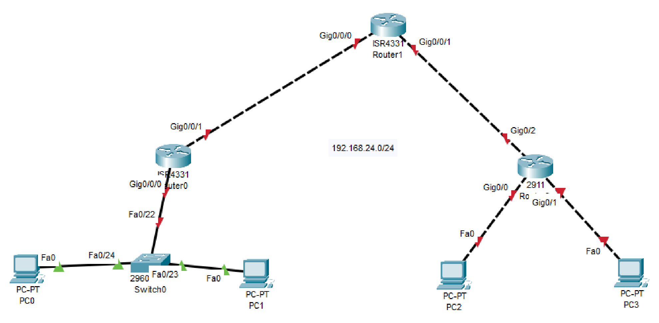

200.200.100.

0

/

2

5

Some things you may want to consider are:

* What class of network is the given address?
* Class c
* How many networks do I have in the diagram?
* 5 Networks

How many host addresses are possible per network/subnetwork?

128

WORKING OUT

In the subnet "200.200.100.0/25," which has a subnet mask of 255.255.255.128, I have a total of 128 IP addresses available.

I’m using a /25 subnet mask, which means I’m borrowing 7 bits for the host portion (32 - 25 = 7). Applying the formula:

2^7 - 2 = 128 - 2 = 126

So, there are 126 usable host addresses per network/subnet in the "200.200.100.0/25" subnet. ***solution***

***shown below***

*of document*

**Portfolio Task – Lab 2 Credit**

**Task**

Aims:

* Using the addressing you carried out in the Pass Task of this lab you must build and implement an addressed network according to the given network diagram below on Packet Tracer (PT)

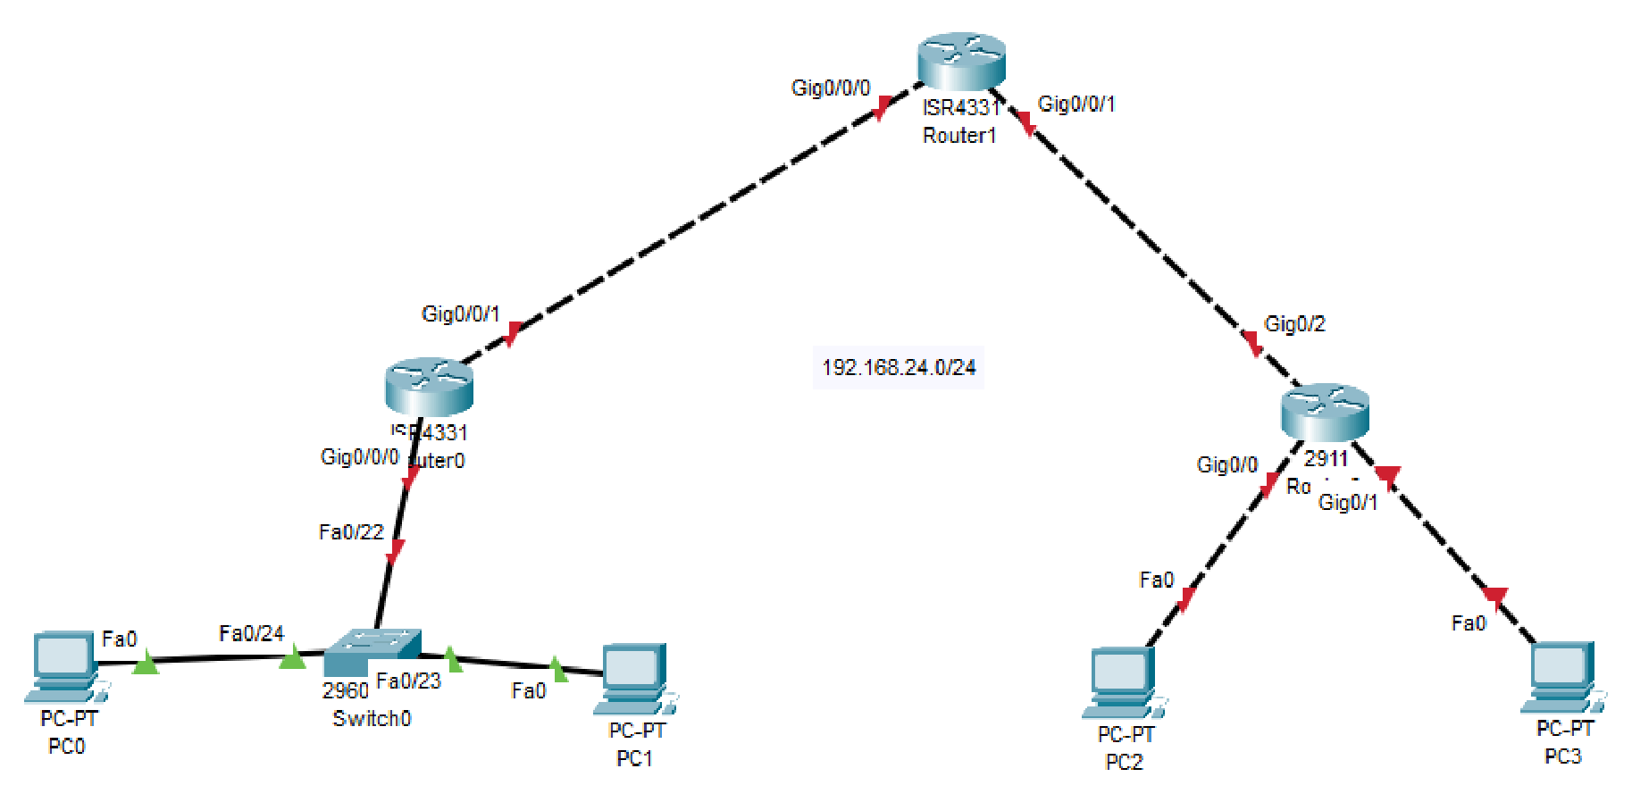

200.200.100.

0

/2

5

Preparation:

* View “[TNE20003 Lab1-P_Student”](https://swinburne.instructure.com/courses/54168/assignments/567094) for instruction on Packet Tracer implementation.

Task Completion

* Upon completion of this task, you are to demonstrate your network implemented on PT. Your lab instructor will then mark you as having completed this task. Your instructor will ask you some questions to allow you to show the depth of your understanding.

Due Date:

All tasks in this lab are to be completed and demonstrated to your Lab instructor preferably during or at the end of the current lab, but if you do not complete the tasks you may demonstrate it at the beginning of your next lab class.

**Portfolio Task – Lab 2**

**Distinction Task**

Aims:

* Demonstrate successful end-to-end connectivity of the addressed network implemented in Packet Tracer from the Credit Task above.

Preparation:

* Using Self-Directed learning find out about static routes
* What are they?
* What are they used for?
* How do you implement them?
* Which device(s) are they placed on?
* Static routes are vital for you to be able to achieve end-to-end Connectivity.

Task Completion

* Upon completion of this task you are to demonstrate and explain your successful implementation of static routes to the lab instructor who will then mark you as having completed this task. Your instructor will ask you some questions to allow you to show the depth of your understanding.

Due Date:

All tasks in this lab are to be completed and demonstrated to your Lab instructor preferably during or at the end of the current lab, but if you do not complete the tasks you may demonstrate it at the beginning of your next lab class.

*~~~~~ End of Lab ~~~~~*